ANOVA Tutorial Sheet Solutions

## QUESTION 1.

Read in data and ;

## X child parent gp par   
## Min. : 1.0 Min. :52.50 Min. :52.50 fd:206 Father:385   
## 1st Qu.:187.2 1st Qu.:62.50 1st Qu.:61.50 fs:179 Mother:361   
## Median :373.5 Median :65.50 Median :65.50 md:185   
## Mean :373.5 Mean :66.05 Mean :65.01 ms:176   
## 3rd Qu.:559.8 3rd Qu.:69.50 3rd Qu.:68.50   
## Max. :746.0 Max. :79.50 Max. :75.50   
## chl   
## Daughter:391   
## Son :355   
##   
##   
##   
##

##   
## Call:  
## lm(formula = parent ~ par, data = MYPEARSON)  
##   
## Residuals:  
## Min 1Q Median 3Q Max   
## -10.2607 -3.2607 0.3761 3.3761 8.3761   
##   
## Coefficients:  
## Estimate Std. Error t value Pr(>|t|)   
## (Intercept) 67.1239 0.2151 312.03 <2e-16 ***  
## parMother -4.3632 0.3092 -14.11 <2e-16 ***  
## ---  
## Signif. codes: 0 '***' 0.001 '**' 0.01 '*' 0.05 '.' 0.1 ' ' 1  
##   
## Residual standard error: 4.221 on 744 degrees of freedom  
## Multiple R-squared: 0.2111, Adjusted R-squared: 0.21   
## F-statistic: 199.1 on 1 and 744 DF, p-value: < 2.2e-16

* ii Child’s height vs father’s height; 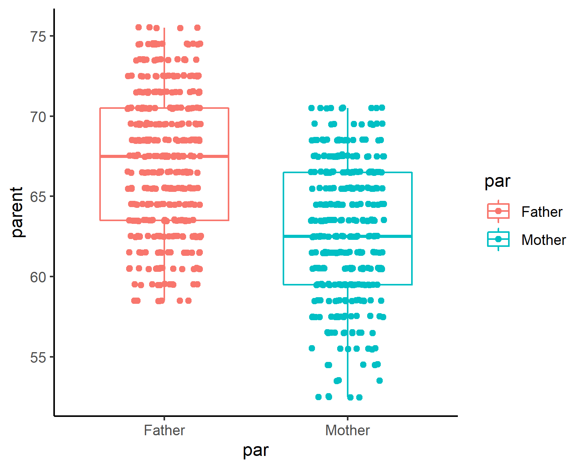
* iii Child’s height vs mother’s height;

## Df Sum Sq Mean Sq F value Pr(>F)   
## par 1 3547 3547 199.1 <2e-16 ***  
## Residuals 744 13255 18   
## ---  
## Signif. codes: 0 '***' 0.001 '**' 0.01 '*' 0.05 '.' 0.1 ' ' 1

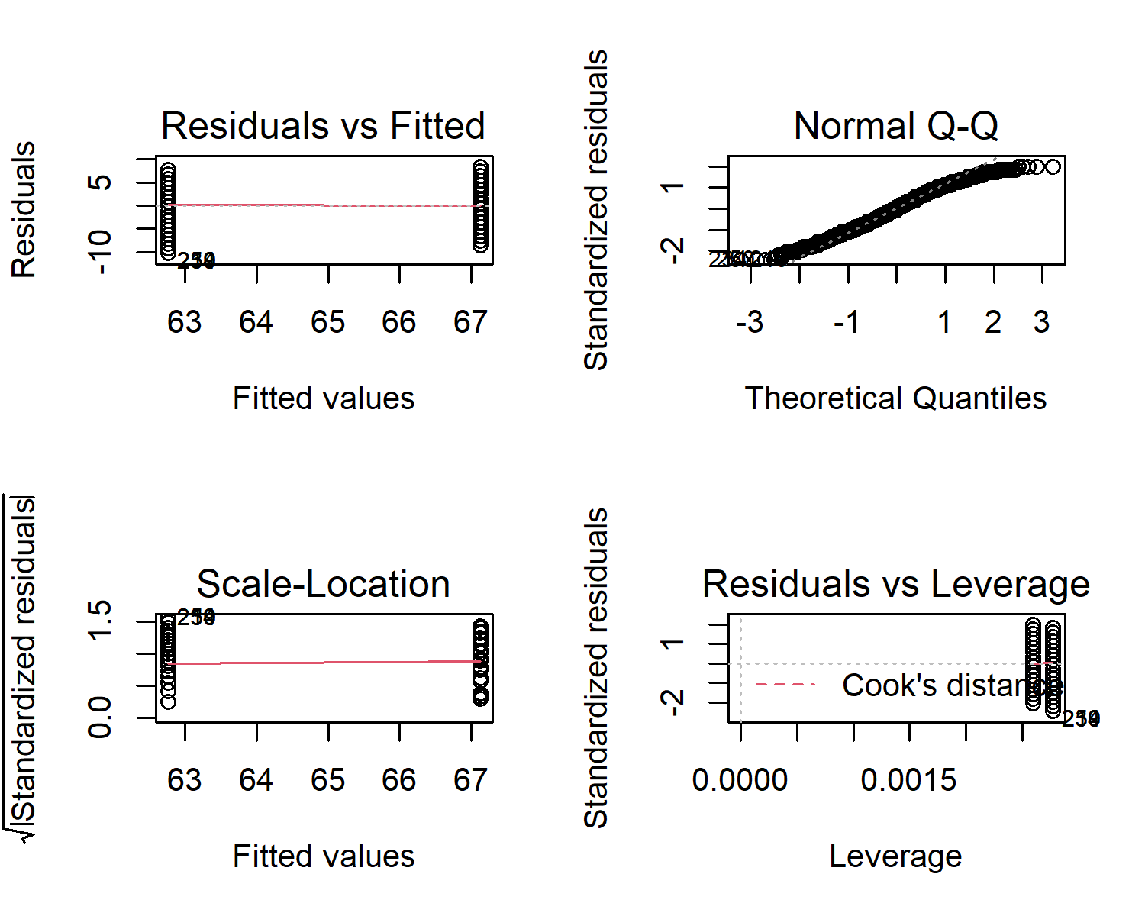

## Tukey Follow Up

## Tukey multiple comparisons of means  
## 95% family-wise confidence level  
##   
## Fit: aov(formula = parent ~ par, data = MYPEARSON)  
##   
## $par  
## diff lwr upr p adj  
## Mother-Father -4.363231 -4.970319 -3.756144 0

## t-test

##   
## Welch Two Sample t-test  
##   
## data: parent by par  
## t = 14.124, df = 743.16, p-value < 2.2e-16  
## alternative hypothesis: true difference in means between group Father and group Mother is not equal to 0  
## 95 percent confidence interval:  
## 3.756744 4.969719  
## sample estimates:  
## mean in group Father mean in group Mother   
## 67.12390 62.76066

## Child

* ii Child’s height vs father’s height; 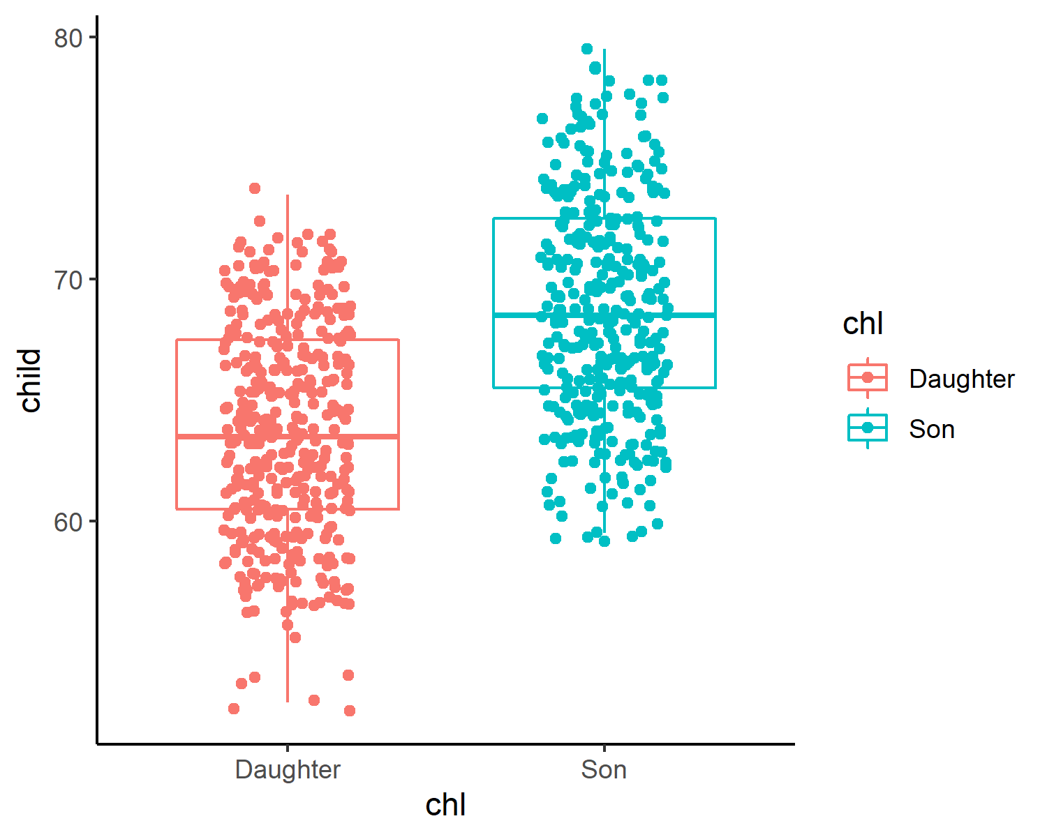
* iii Child’s height vs mother’s height;

## Df Sum Sq Mean Sq F value Pr(>F)   
## chl 1 4742 4742 236 <2e-16 ***  
## Residuals 744 14950 20   
## ---  
## Signif. codes: 0 '***' 0.001 '**' 0.01 '*' 0.05 '.' 0.1 ' ' 1

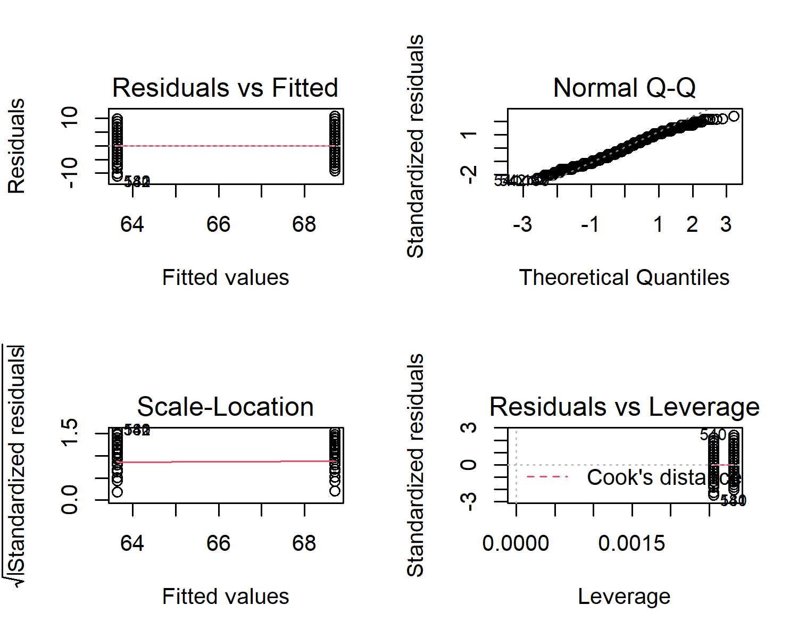

## Tukey Follow Up

## Tukey multiple comparisons of means  
## 95% family-wise confidence level  
##   
## Fit: aov(formula = child ~ chl, data = MYPEARSON)  
##   
## $chl  
## diff lwr upr p adj  
## Son-Daughter 5.048586 4.403437 5.693735 0

## t-test

##   
## Welch Two Sample t-test  
##   
## data: child by chl  
## t = -15.324, df = 727.84, p-value < 2.2e-16  
## alternative hypothesis: true difference in means between group Daughter and group Son is not equal to 0  
## 95 percent confidence interval:  
## -5.695396 -4.401776  
## sample estimates:  
## mean in group Daughter mean in group Son   
## 63.64578 68.69437

## BIGGER ANOVA

## Height Type   
## Min. :52.50 Daughter:391   
## 1st Qu.:61.50 Son :355   
## Median :65.50 Father :385   
## Mean :65.53 Mother :361   
## 3rd Qu.:69.50   
## Max. :79.50

## Df Sum Sq Mean Sq F value Pr(>F)   
## Type 3 8690 2896 152.8 <2e-16 ***  
## Residuals 1488 28206 19   
## ---  
## Signif. codes: 0 '***' 0.001 '**' 0.01 '*' 0.05 '.' 0.1 ' ' 1

## Tukey multiple comparisons of means  
## 95% family-wise confidence level  
##   
## Fit: aov(formula = Height ~ Type, data = Stacked_MYPEARSON)  
##   
## $Type  
## diff lwr upr p adj  
## Son-Daughter 5.0485861 4.227679 5.86949377 0.0000000  
## Father-Daughter 3.4781161 2.674147 4.28208550 0.0000000  
## Mother-Daughter -0.8851152 -1.702439 -0.06779101 0.0277309  
## Father-Son -1.5704701 -2.394416 -0.74652410 0.0000063  
## Mother-Son -5.9337014 -6.770683 -5.09671929 0.0000000  
## Mother-Father -4.3632313 -5.183607 -3.54285542 0.0000000

##   
## Pairwise comparisons using t tests with pooled SD   
##   
## data: Height and Type   
##   
## Daughter Son Father   
## Son < 2e-16 - -   
## Father < 2e-16 6.3e-06 -   
## Mother 0.032 < 2e-16 < 2e-16  
##   
## P value adjustment method: bonferroni

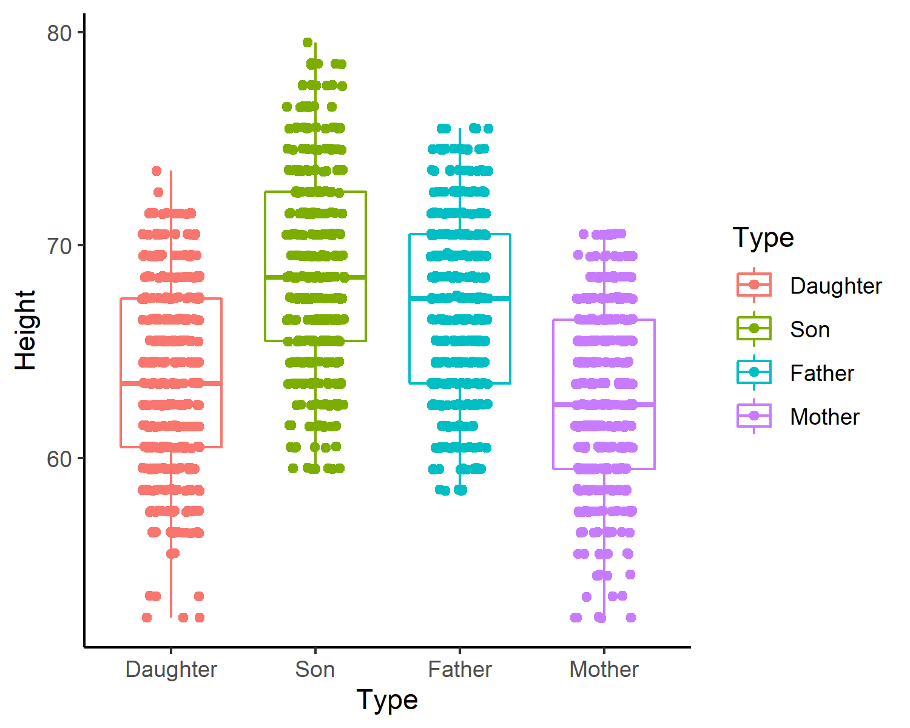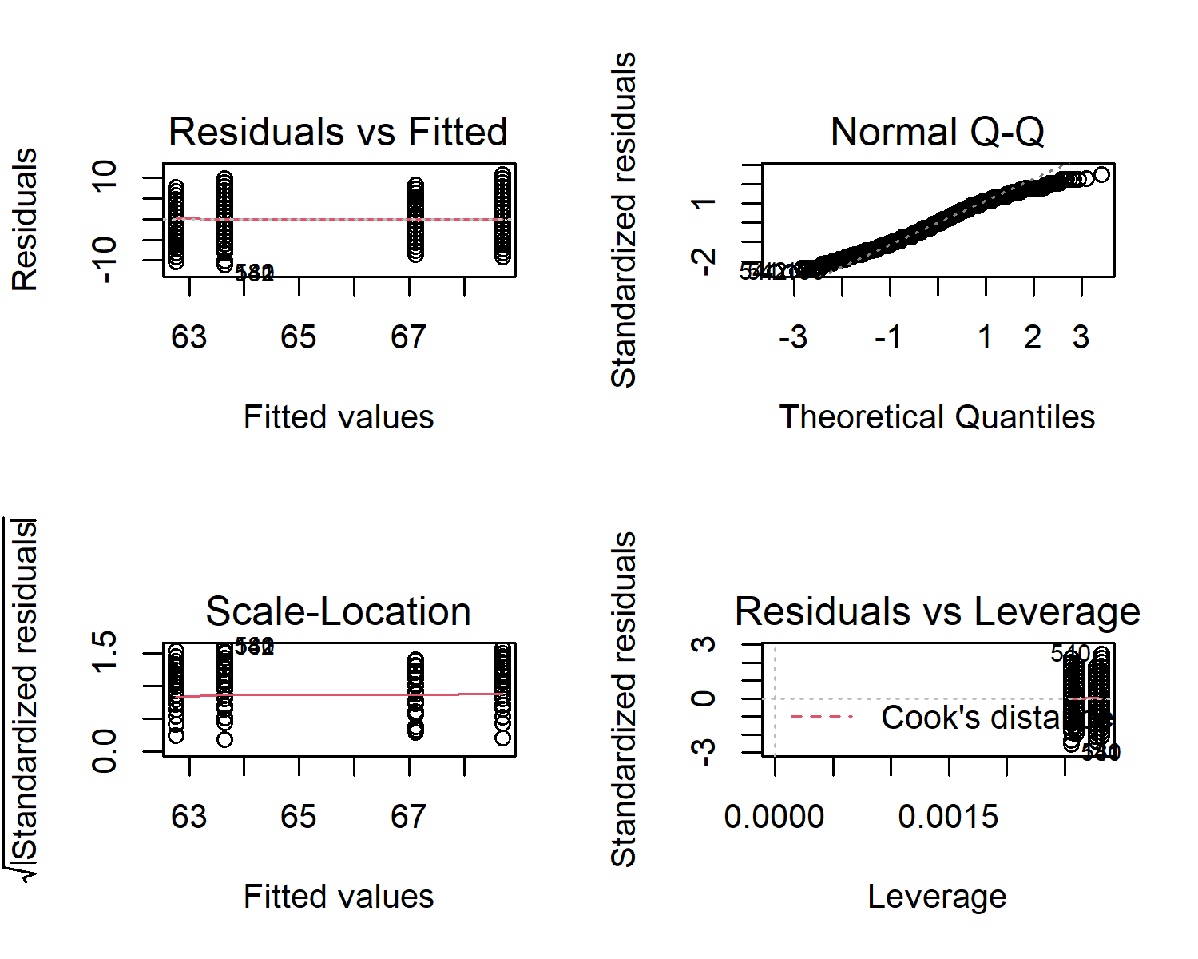

## Tidyverse Version

## Coefficient covariances computed by hccm()

## ANOVA Table (type II tests)  
##   
## Effect DFn DFd F p p<.05 ges  
## 1 Type 3 1488 152.806 2.51e-86 * 0.236

|  |  |  |  |  |  |  |  |  |
| --- | --- | --- | --- | --- | --- | --- | --- | --- |
| term | group1 | group2 | null.value | estimate | conf.low | conf.high | p.adj | p.adj.signif |
| Type | Daughter | Son | 0 | 5.0485861 | 4.227678 | 5.8694938 | 0.00e+00 | **** |
| Type | Daughter | Father | 0 | 3.4781161 | 2.674147 | 4.2820855 | 0.00e+00 | **** |
| Type | Daughter | Mother | 0 | -0.8851152 | -1.702440 | -0.0677910 | 2.77e-02 | * |
| Type | Son | Father | 0 | -1.5704701 | -2.394416 | -0.7465241 | 6.30e-06 | **** |
| Type | Son | Mother | 0 | -5.9337014 | -6.770683 | -5.0967193 | 0.00e+00 | **** |
| Type | Father | Mother | 0 | -4.3632313 | -5.183607 | -3.5428554 | 0.00e+00 | **** |

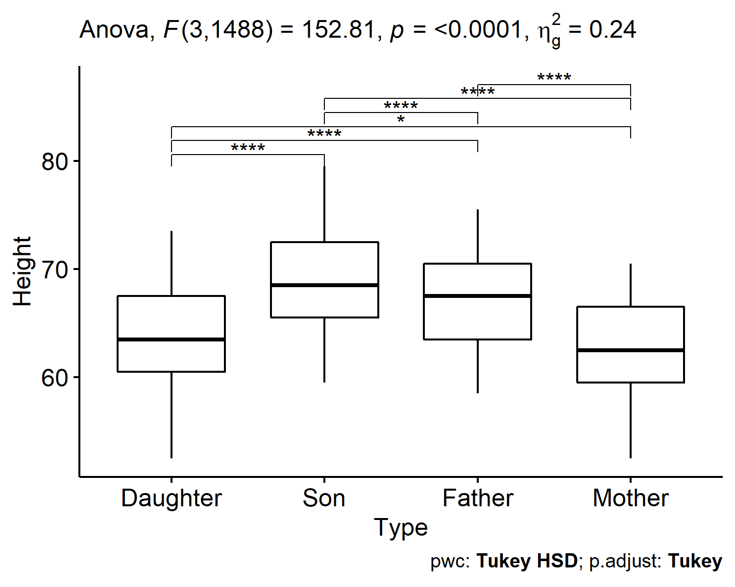

|  |  |  |  |  |  |  |  |  |  |
| --- | --- | --- | --- | --- | --- | --- | --- | --- | --- |
| .y. | group1 | group2 | n1 | n2 | statistic | df | p | p.adj | p.adj.signif |
| Height | Daughter | Son | 391 | 355 | -15.323713 | 727.8380 | 0e+00 | 0.0e+00 | **** |
| Height | Daughter | Father | 391 | 385 | -11.197993 | 773.9853 | 0e+00 | 0.0e+00 | **** |
| Height | Daughter | Mother | 391 | 361 | 2.847687 | 749.3554 | 5e-03 | 5.0e-03 | ** |
| Height | Son | Father | 355 | 385 | 4.792627 | 721.0755 | 2e-06 | 2.4e-06 | **** |
| Height | Son | Mother | 355 | 361 | 18.096591 | 703.9580 | 0e+00 | 0.0e+00 | **** |
| Height | Father | Mother | 385 | 361 | 14.123505 | 743.1565 | 0e+00 | 0.0e+00 | **** |

